**Reference No:**

**Damage Report Date:**  01/03/2017

In Container

In Warehouse

Product: HS5

Serial Number: AFVO01160

*Insert* Picture:

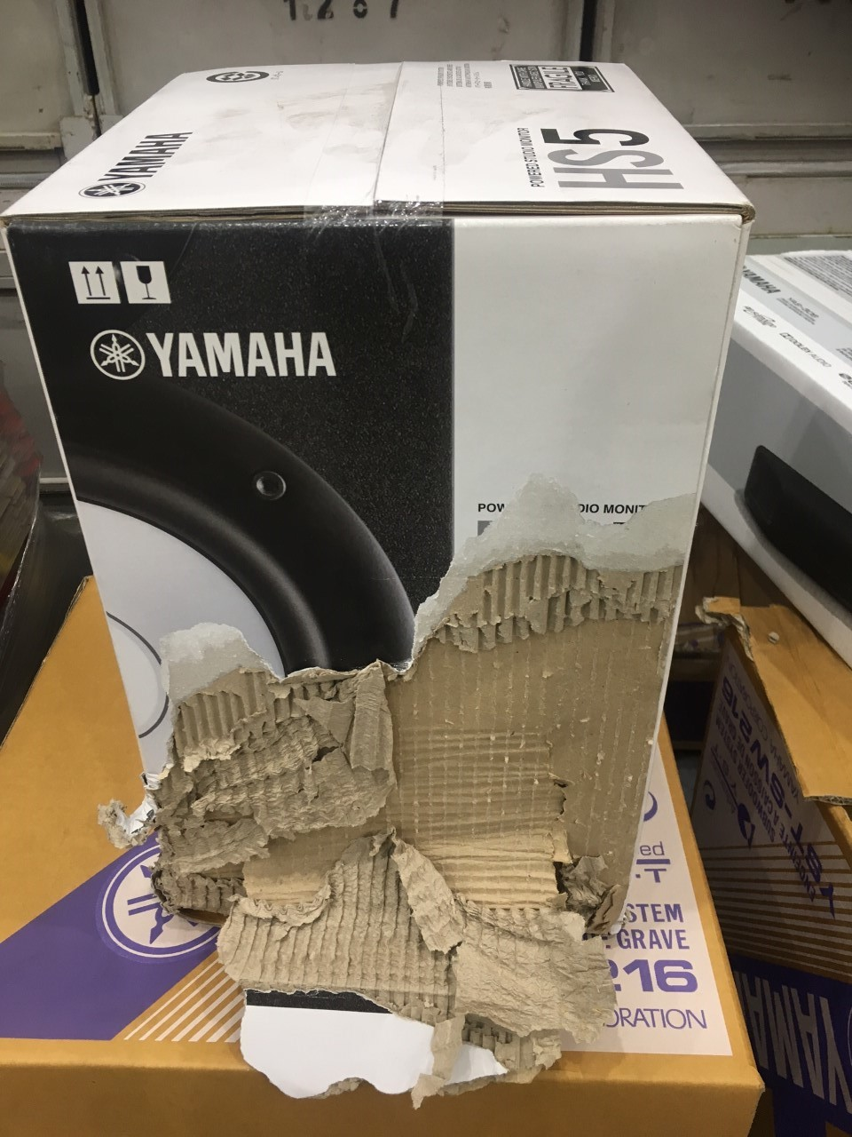

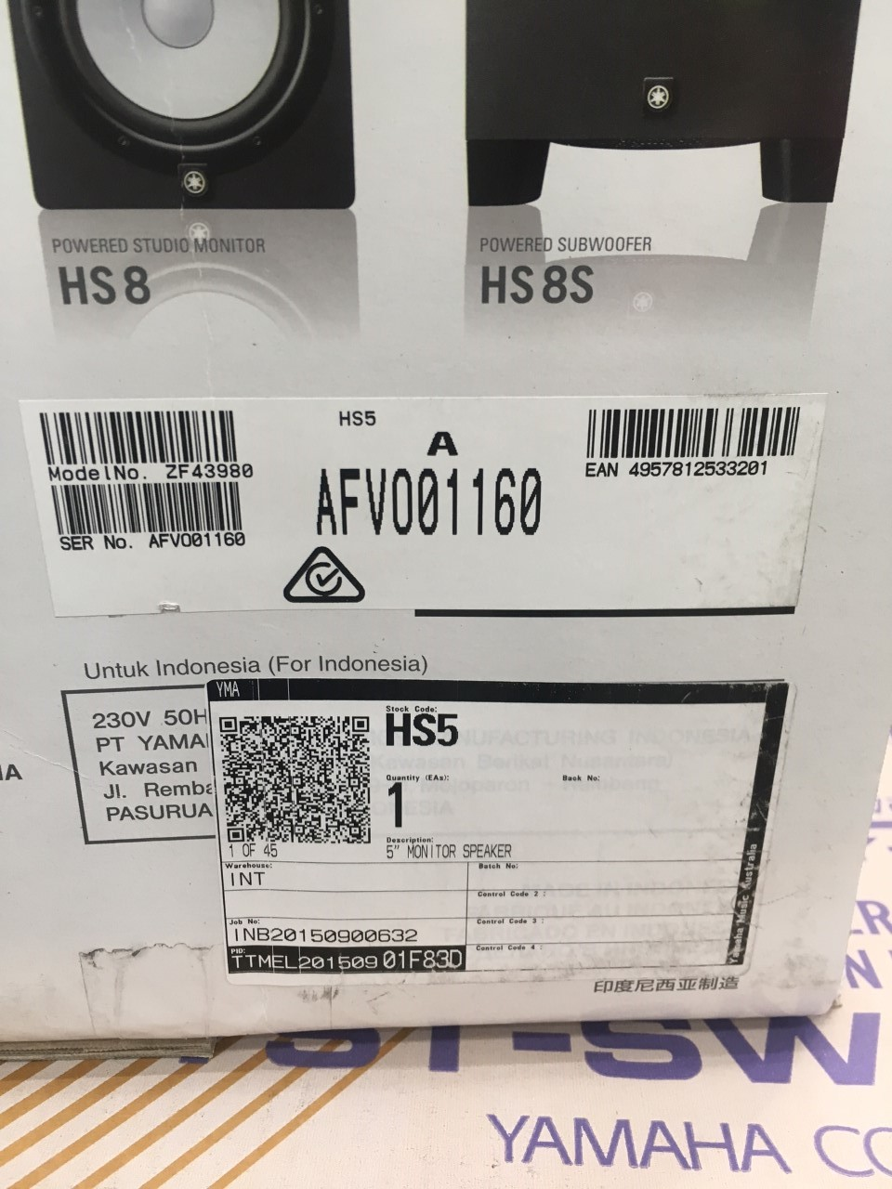

**How was it damaged?**

Ware house Damage.

Image 1) Carton Damage

Image 2) PID, Serial Number, EAN

Reported by Kalecia Kirby